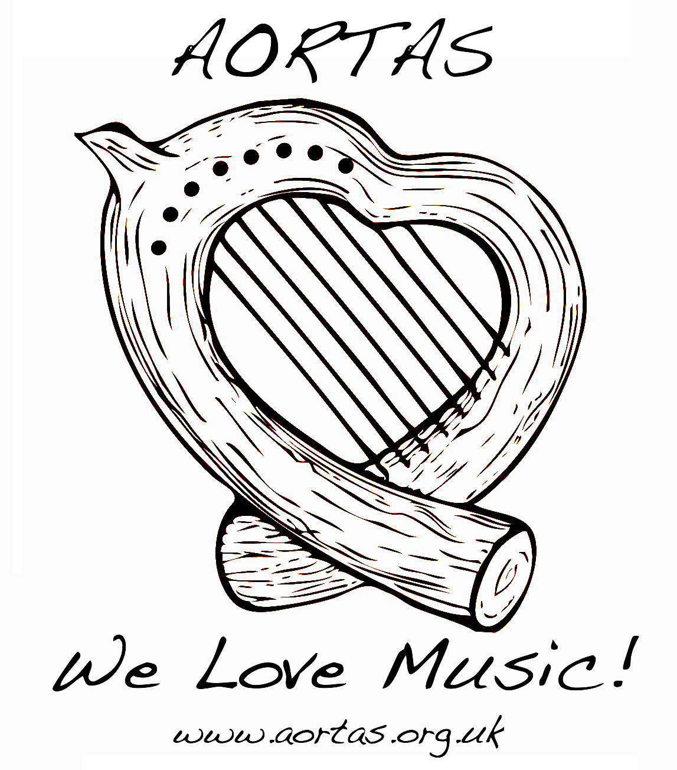
AORTAS SongCircle

Feedback Sheet – give to listeners this side down, first impressions other side!

Songwriter: Working Title: Date:

Chords/Lyrics (chorus or refrain in bold):

FEEDBACK/COMMENTS FROM:

SIGNED AND DATED:

